Charmaine Chan
Vernon Gutierrez
Francis Macam
Mark Tan

The main screen contains user controls to create a random song, and to pause, play, and stop playing the song. The song generator creates a song based on the music theory and several input parameters. Each song consists of verses, which are made up of phrases, which are made up of measures. The song is composed over several parts which arrange notes based on the generated harmony, melody, and rhythm. The notes are translated into a grid which is displayed by a grid screen.

Noun Extraction:
Main Screen
Controls
Grid
Grid Screen
Song Generator
Song
Verse
Phrase
Measure
Part
Harmony
Melody
Rhythm
Note
Input Parameters
Music Theory

CRC Cards
CLASS
MainScreen
RESPONSIBILITY
- Contains the GridPanel to display on the screen
- Accepts data input from the user and sends them to the ParametersPanel
- Contains the PlayButton and sends message to turn the music on or off
- Contains the RandomizeButton and sends message to randomize a new song

COLLABORATION
- GridPanel
- ParametersPanel
- PlayButton
- RandomizeButton

CLASS
GridPanel
RESPONSIBILITY
- Sends a message to the MainScreen to update the screen with a new grid
- Accepts information from the SongRandomizer to display a new song on the grid
COLLABORATION
- MainScreen
- SongRandomizer

CLASS
ParametersPanel
RESPONSIBILITY
- Accepts information which was inputted by the user from the MainScreen
- Passes the information to the SongRandomizer for it to be able to randomize new songs
COLLABORATION
- MainScreen
- SongRandomizer

CLASS
RandomizeButton
RESPONSIBILITY
- Accepts message from the MainScreen to randomize music
- Passes the message to the SongRandomizer
COLLABORATION
- MainScreen
- SongRandomizer

CLASS
PlayButton
RESPONSIBILITY
- Accepts information from the MainScreen to play or stop the music
COLLABORATION
- MainScreen

CLASS
SongRandomizer
RESPONSIBILITY
- Accepts data from the ParametersPanel for generating a random song.
- Generates the song once it receives the go signal from the RandomizeButton
- Generates a Song
- Gives the new song information to display in the GridPanel
COLLABORATION
- GridPanel
- ParametersPanel
- RandomizeButton
- Song

CLASS
Verse
RESPONSIBILITY
- Sends information to Song
- Accepts information from Rhythm
- Accepts information from MusicTheory
- Accepts information from Harmony
- Get information from Phrase to create a verse
COLLABORATION
- Song
- Rhythm
- MusicTheory
- Harmony
- Phrase

CLASS
Song
RESPONSIBILITY
- Generates a song when a message is sent from SongRandomizer
- Accepts data from MusicTheory to generate a song
- Get information from Verse to create a song
COLLABORATION
- SongRandomizer
- Verse
- MusicTheory

CLASS
Measure
RESPONSIBILITY
- Sends information to Phrase to create a song
- Accepts data from MusicTheory to generate a song
COLLABORATION
- Phrase
- MusicTheory

CLASS
Phrase
RESPONSIBILITY
- Sends information to Verse
- Accepts information from Rhythm
- Accepts information from MusicTheory
- Accepts information from Harmony
- Get information from Measure to create a verse
COLLABORATION
- Verse
- Rhythm
- MusicTheory
- Measure
- Harmony

CLASS
Harmony
RESPONSIBILITY
- Accepts information from MusicTheory to generate a rhythm for the song
- Sends new information to Phrase
- Sends new information to Verse
COLLABORATION
- MusicTheory
- Phrase
- Verse

CLASS
ClassicalTheory
RESPONSIBILITY
- Sends information to MusicTheory to generate songs
COLLABORATION
- MusicTheory (parent class)

CLASS
Rhythm
RESPONSIBILITY
- Accepts information from MusicTheory to generate a rhythm for the song
- Sends new information to Phrase
- Sends new information to Verse
COLLABORATION
- MusicTheory
- Phrase
- Verse

CLASS
MusicTheory
RESPONSIBILITY
- Accepts information from ClassicalTheory
- Sends a message to Song on how to generate a song
- Sends a message to Rhythm on how to generate a song
- Sends a message to Verse on how to generate a song
- Sends a message to Phrase on how to generate a song
- Sends a message to Harmony on how to generate a song
COLLABORATION
- ClassicalTheory (subclass)
- Song
- Rhythm
- Verse
- Phrase
- Harmony

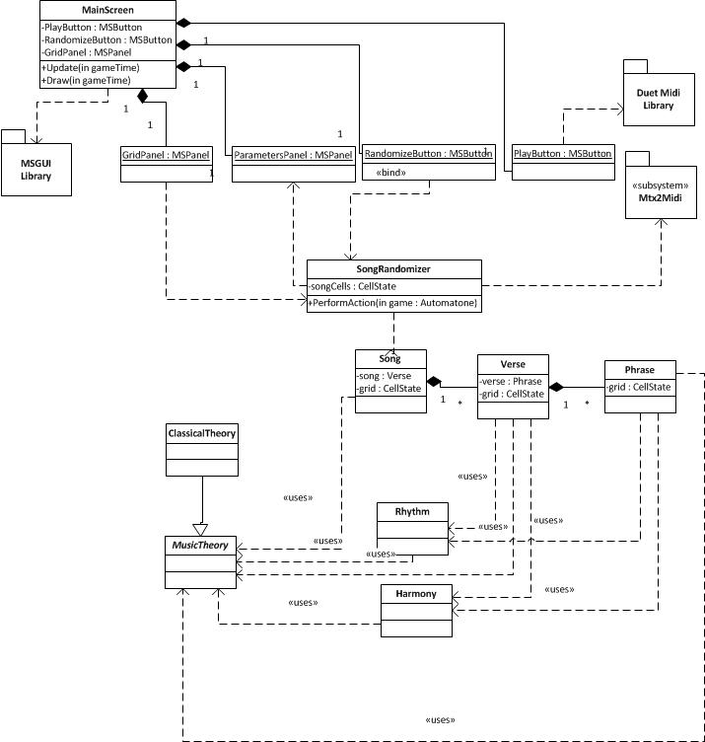
Class Diagram

